Program 9: Develop a Web page(s) with suitable HTML elements to demonstrate Bootstrap 5.0 framework classes for Badges, Progress bar, spinners and Pagination.

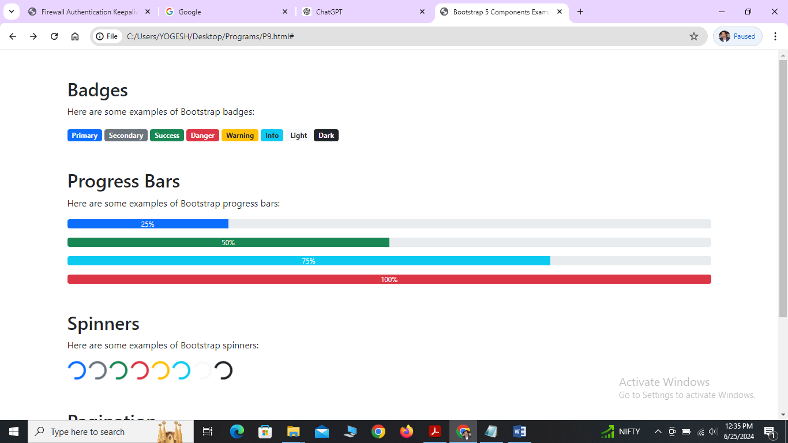

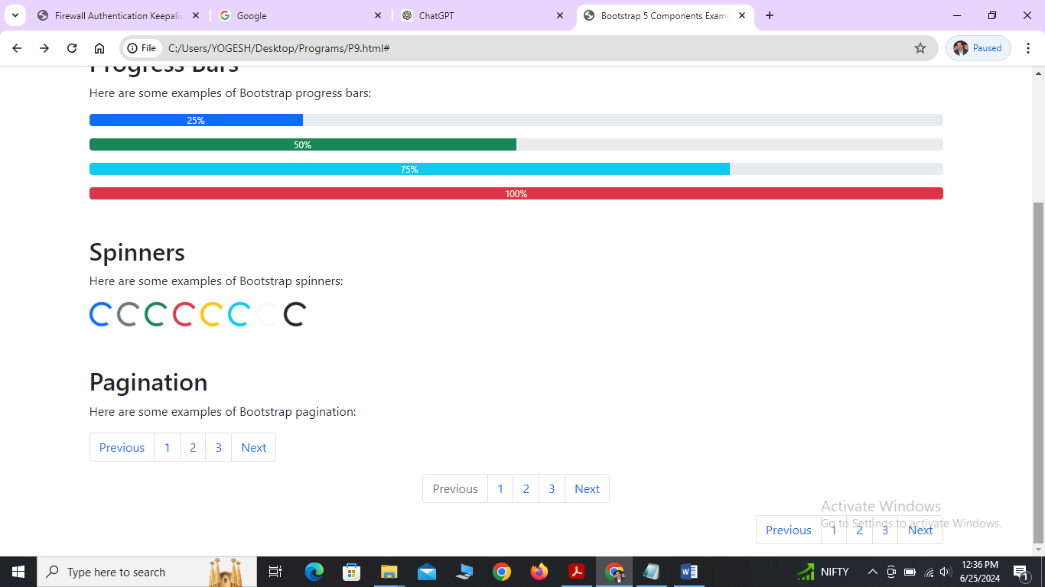

**Programs:**

<!DOCTYPE html>

<html lang="en">

<head>

<meta charset="UTF-8">

<meta name="viewport" content="width=device-width, initial-scale=1.0">

<title>Bootstrap 5 Components Example</title>

<link href="https://cdn.jsdelivr.net/npm/bootstrap@5.0.2/dist/css/bootstrap.min.css" rel="stylesheet">

<script src="https://cdn.jsdelivr.net/npm/@popperjs/core@2.9.2/dist/umd/popper.min.js"></script>

<script src="https://cdn.jsdelivr.net/npm/bootstrap@5.0.2/dist/js/bootstrap.min.js"></script>

</head>

<body>

<!-- Container -->

<div class="container mt-5">

<!-- Badges -->

<section>

<h2>Badges</h2>

<p>Here are some examples of Bootstrap badges:</p>

<span class="badge bg-primary">Primary</span>

<span class="badge bg-secondary">Secondary</span>

<span class="badge bg-success">Success</span>

<span class="badge bg-danger">Danger</span>

<span class="badge bg-warning text-dark">Warning</span>

<span class="badge bg-info text-dark">Info</span>

<span class="badge bg-light text-dark">Light</span>

<span class="badge bg-dark">Dark</span>

</section>

<!-- Progress Bars -->

<section class="mt-5">

<h2>Progress Bars</h2>

<p>Here are some examples of Bootstrap progress bars:</p>

<div class="progress mb-3">

<div class="progress-bar" role="progressbar" style="width: 25%;" aria-valuenow="25" aria-valuemin="0" aria-valuemax="100">25%</div>

</div>

<div class="progress mb-3">

<div class="progress-bar bg-success" role="progressbar" style="width: 50%;" aria-valuenow="50" aria-valuemin="0" aria-valuemax="100">50%</div>

</div>

<div class="progress mb-3">

<div class="progress-bar bg-info" role="progressbar" style="width: 75%;" aria-valuenow="75" aria-valuemin="0" aria-valuemax="100">75%</div>

</div>

<div class="progress">

<div class="progress-bar bg-danger" role="progressbar" style="width: 100%;" aria-valuenow="100" aria-valuemin="0" aria-valuemax="100">100%</div>

</div>

</section>

<!-- Spinners -->

<section class="mt-5">

<h2>Spinners</h2>

<p>Here are some examples of Bootstrap spinners:</p>

<div class="spinner-border text-primary" role="status">

<span class="visually-hidden">Loading...</span>

</div>

<div class="spinner-border text-secondary" role="status">

<span class="visually-hidden">Loading...</span>

</div>

<div class="spinner-border text-success" role="status">

<span class="visually-hidden">Loading...</span>

</div>

<div class="spinner-border text-danger" role="status">

<span class="visually-hidden">Loading...</span>

</div>

<div class="spinner-border text-warning" role="status">

<span class="visually-hidden">Loading...</span>

</div>

<div class="spinner-border text-info" role="status">

<span class="visually-hidden">Loading...</span>

</div>

<div class="spinner-border text-light" role="status">

<span class="visually-hidden">Loading...</span>

</div>

<div class="spinner-border text-dark" role="status">

<span class="visually-hidden">Loading...</span>

</div>

</section>

<!-- Pagination -->

<section class="mt-5">

<h2>Pagination</h2>

<p>Here are some examples of Bootstrap pagination:</p>

<nav aria-label="Page navigation example">

<ul class="pagination">

<li class="page-item"><a class="page-link" href="#">Previous</a></li>

<li class="page-item"><a class="page-link" href="http://google.com">1</a></li>

<li class="page-item"><a class="page-link" href="#">2</a></li>

<li class="page-item"><a class="page-link" href="#">3</a></li>

<li class="page-item"><a class="page-link" href="#">Next</a></li>

</ul>

</nav>

<nav aria-label="Page navigation example">

<ul class="pagination justify-content-center">

<li class="page-item disabled">

<a class="page-link" href="#" tabindex="-1" aria-disabled="true">Previous</a>

</li>

<li class="page-item"><a class="page-link" href="#">1</a></li>

<li class="page-item"><a class="page-link" href="#">2</a></li>

<li class="page-item"><a class="page-link" href="#">3</a></li>

<li class="page-item">

<a class="page-link" href="#">Next</a>

</li>

</ul>

</nav>

<nav aria-label="Page navigation example">

<ul class="pagination justify-content-end">

<li class="page-item"><a class="page-link" href="#">Previous</a></li>

<li class="page-item"><a class="page-link" href="#">1</a></li>

<li class="page-item"><a class="page-link" href="#">2</a></li>

<li class="page-item"><a class="page-link" href="#">3</a></li>

<li class="page-item"><a class="page-link" href="#">Next</a></li>

</ul>

</nav>

</section>

</div>

</body>

</html>

**Explanation:**

**Head Section**

1. **Meta Tags and Title**:
   * <meta charset="UTF-8">: Sets the character encoding to UTF-8.
   * <meta name="viewport" content="width=device-width, initial-scale=1.0">: Ensures proper scaling on mobile devices.
   * <title>Bootstrap 5 Example: Badges, Progress Bars, Spinners, and Pagination</title>: Sets the title of the webpage.
2. **Bootstrap CSS and JS**:
   * <link href="https://cdn.jsdelivr.net/npm/bootstrap@5.0.2/dist/css/bootstrap.min.css" rel="stylesheet">: Includes Bootstrap 5 CSS.
   * <script src="https://cdn.jsdelivr.net/npm/@popperjs/core@2.9.2/dist/umd/popper.min.js"></script>: Includes Popper.js for Bootstrap components.
   * <script src="https://cdn.jsdelivr.net/npm/bootstrap@5.0.2/dist/js/bootstrap.min.js"></script>: Includes Bootstrap 5 JavaScript.

#### Body Section

##### Badges

* **Badges**: Used to display additional information.
  + <span class="badge bg-secondary">4</span>: A badge within a button showing the number 4.
  + <span class="badge bg-success">New</span>: A badge within a heading indicating "New".
  + <a href="#" class="badge bg-info">Info Link</a>: A badge styled link.

##### Progress Bars

* **Progress Bars**: Display progress of a task.
  + <div class="progress-bar" role="progressbar" style="width: 25%;" aria-valuenow="25" aria-valuemin="0" aria-valuemax="100">25%</div>: A progress bar filled to 25%.
  + Different colors (bg-success, bg-info, bg-warning) indicate various states of progress.

##### Spinners

* **Spinners**: Indicate loading or processing states.
  + <div class="spinner-border text-primary" role="status">: Creates a primary-colored spinner.
  + Different colors (text-primary, text-secondary, text-success, etc.) indicate various states.

##### Pagination

**Pagination**: Allows navigation through multiple pages of content.

* <ul class="pagination">: Creates a pagination list.
* <li class="page-item"><a class="page-link" href="#">1</a></li>: Each page link is an item within the pagination list.